# ABC’s Inventory Management System

## Test Script

|  |  |  |  |  |  |
| --- | --- | --- | --- | --- | --- |
| **Test Name** | | Send Product Without Choosing Destination (Test Case SPT006) | | | |
| **Use Case Tested** | | Send Product | | | |
| **Test Description** | | This test tests if the system can send product and its normal quantity without selecting the destination. | | | |
| **Pre-Conditions** | | Meta data must exist, product and product details like product item code, location ID and product quantity. | | | |
| **Post-Conditions** | | Appropriate Alert message is displayed | | | |
| **Notes** | | This test assumes that the user knows the destination name, product item code. | | | |
| **Result (Pass/Fail/Warning/ Incomplete)** | | Pass | | | |
|  | **Test Step** | | **Expected Test Results** | **P** | **F** |
| 1. | Select Send Product Button from home page | | Display the Send Product page | P |  |
| 2. | Do not select any destination location | |  | P |  |
| 3. | Enter the description for this transfer | | Description text area displays user inputs | P |  |
| 4. | Select the product item code in the table on the left | | System waits for hitting the “Add to Cart” Button | P |  |
| 5. | Click on the “Add To Cart” Button | | Appropriate Alert message is displayed and asking for choosing the destination | P |  |

## Data Set 1

|  |  |
| --- | --- |
| **Test Data Table** | |
| **Destination Location** | N/a |
| **Description** | Send Product From Warehouse to Oxford Store |
| **Product Item Code** | Z2100 |
| **Quantity** | N/A |

# Result Screenshots

The screenshots of the result on each test step for each data set are given below:

**Step 1**

Don’t select the destination location

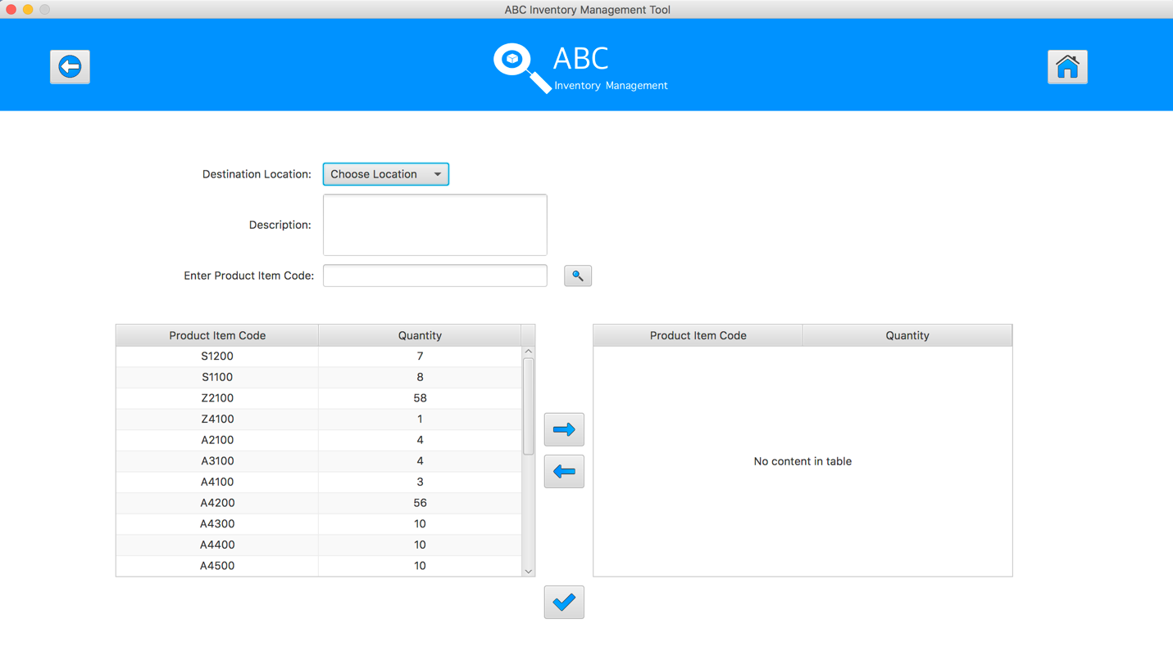

**Step 2**

Enter the description for this transfer

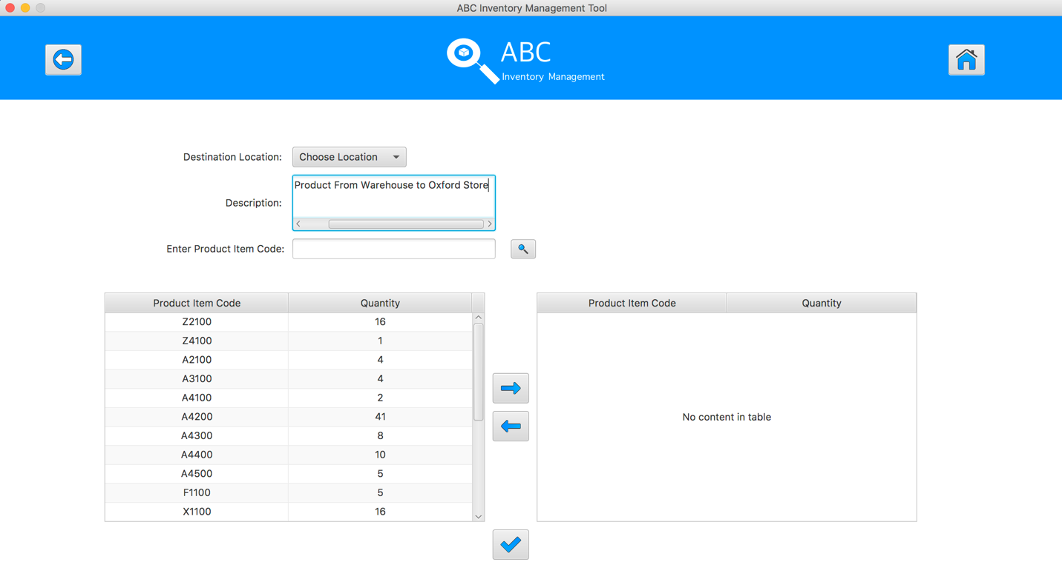

**Step 3**

Select the product item code in the table on the left

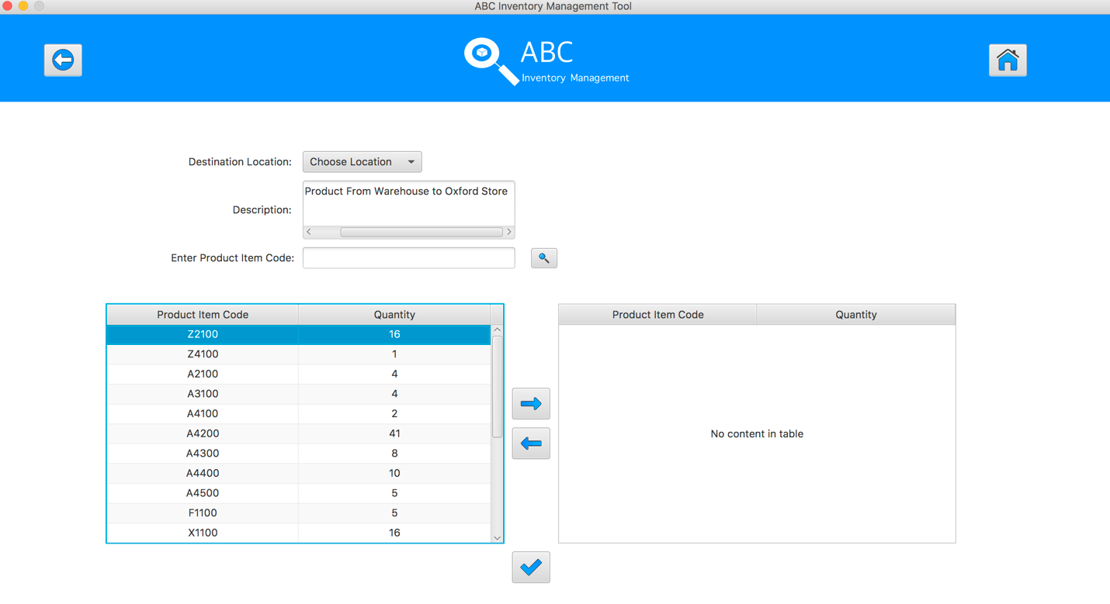

**Step 4**

Click on the “Add To Cart” Button. An alert notify that user need to choose the destination before adding product items to cart

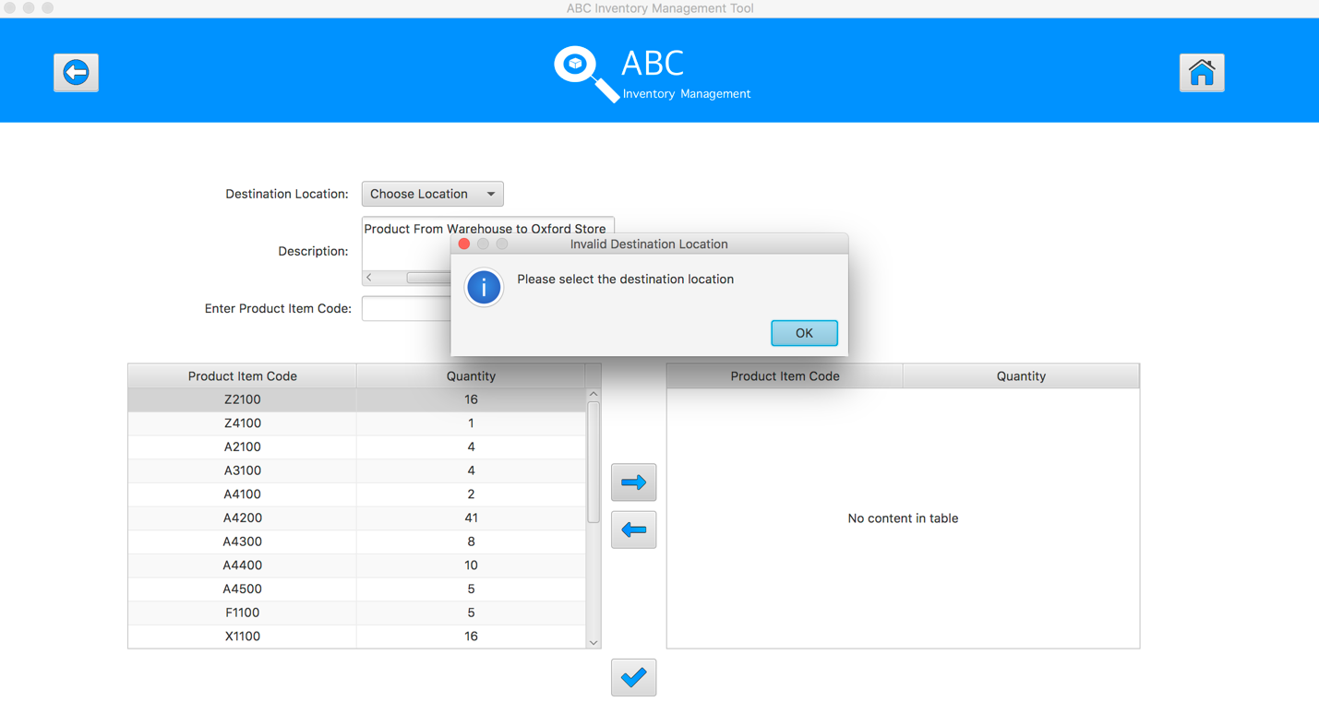

## Data Set 2

|  |  |  |  |
| --- | --- | --- | --- |
| **Test Data Table** | | | |
| **Destination Location** | Epping Store | | |
| **Description** | Send Product From Warehouse to Epping Store | | |
| **Product Item Code** | A4500 | A4500 | A4200 |
| **Quantity** | 2 | N/A | 6 |

# Result Screenshots

The screenshots of the result on each test step for each data set are given below:

**Step 1**

Select the destination location



**Step 2**

Enter the description for this transfer

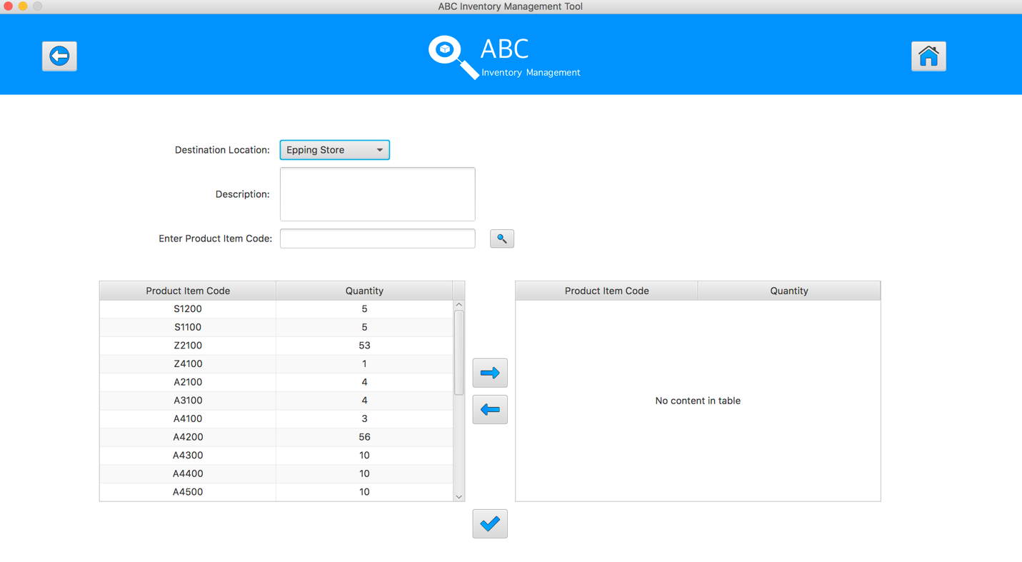

**Step 3**

Select the product item code in the table on the left

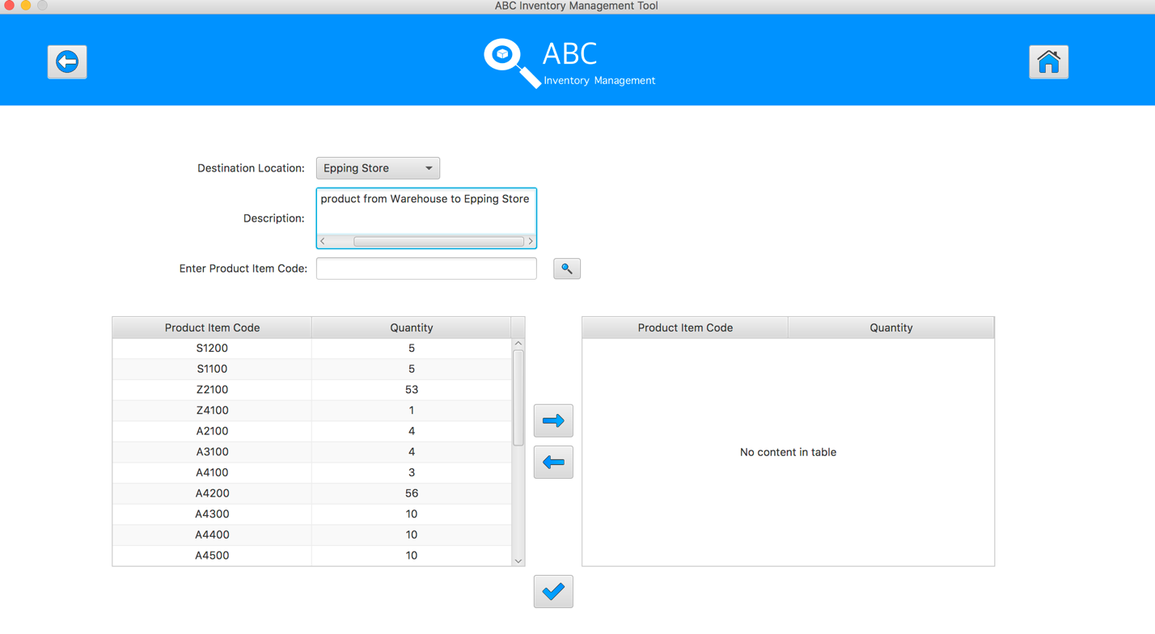

**Step 4**

Select the product item code in the table on the left

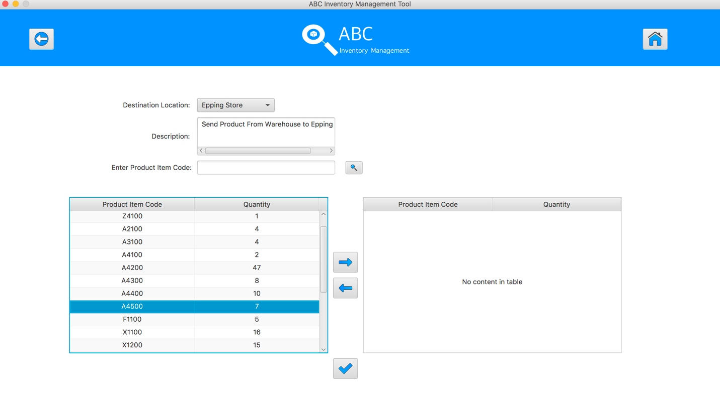

**Step 5**

Click on the “Add To Cart” Button

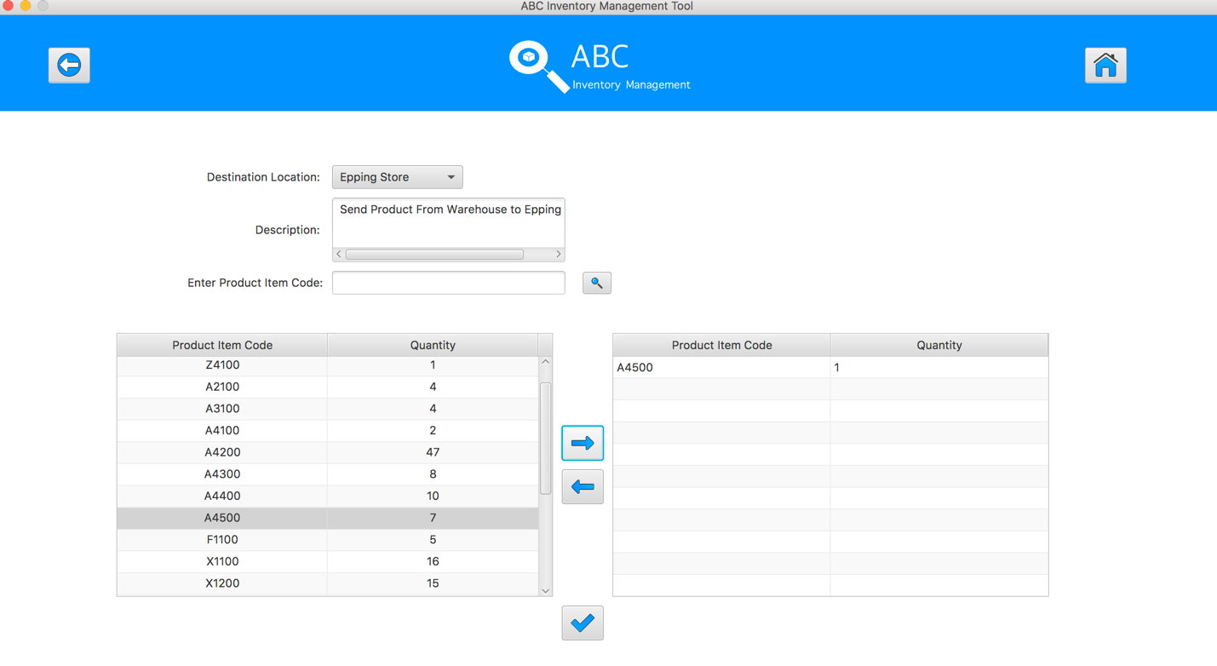

**Step 6**

Double click to the quantity cell in selected cart table

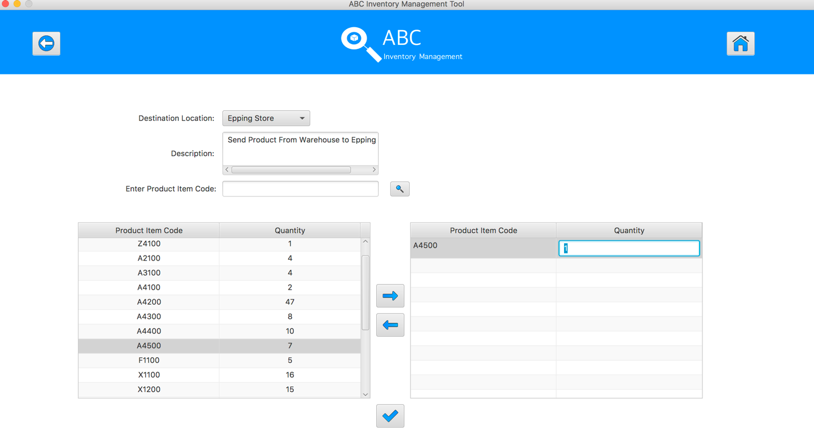

**Step 7**

Enter the desirable number

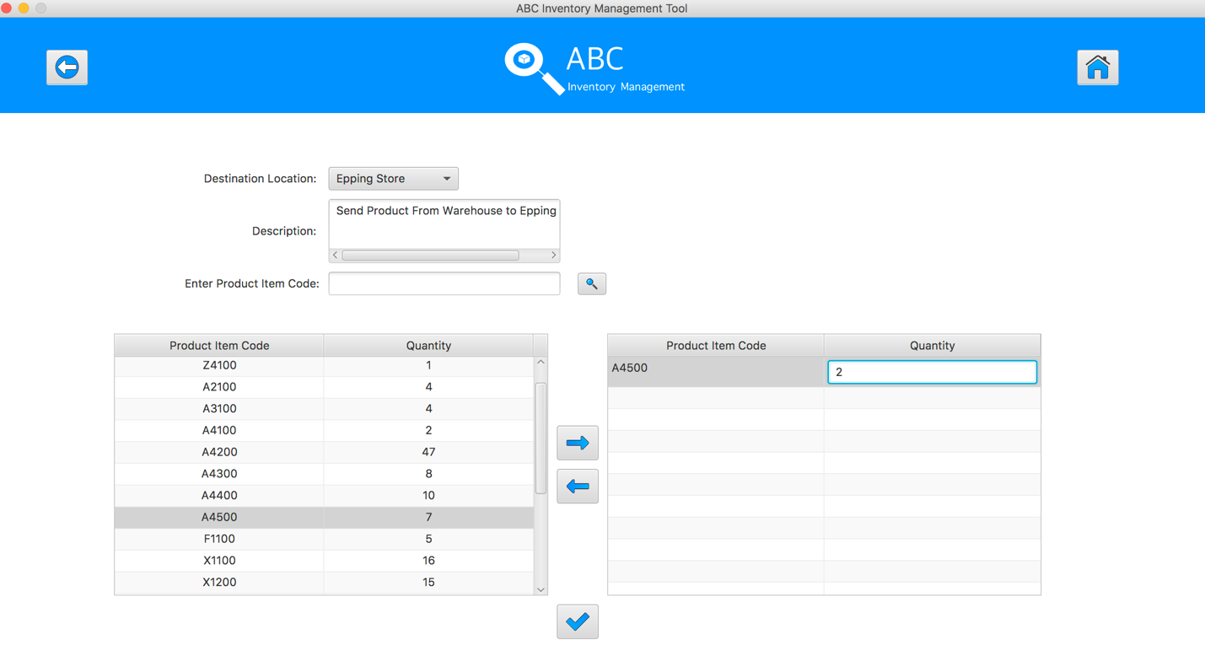

**Step 8**

Hit enter key to confirm this edited quantity

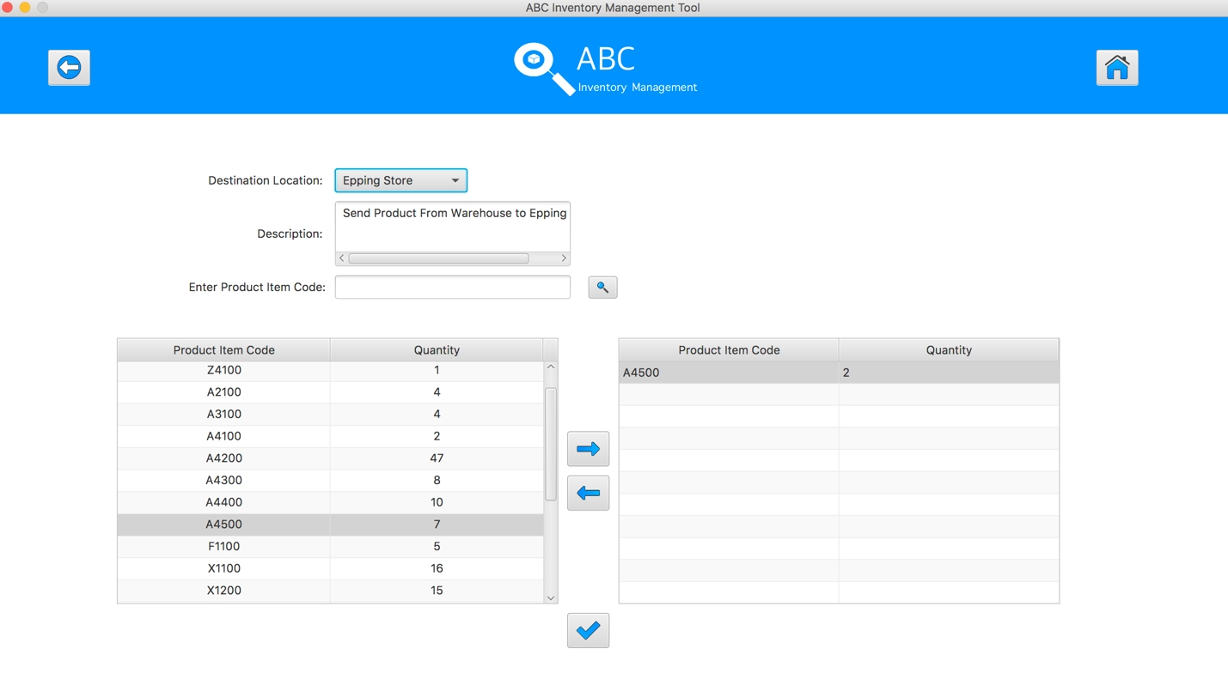

**Step 9**

Select the same product item code which was added to cart table in the table on the left

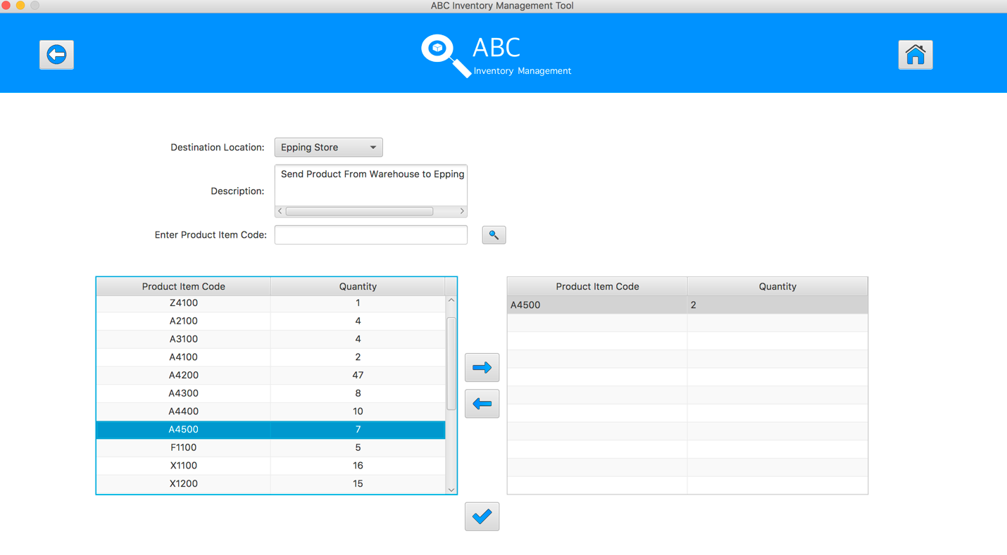

**Step 10**

System displays an alert message to notify that user cannot add this product to the cart again.

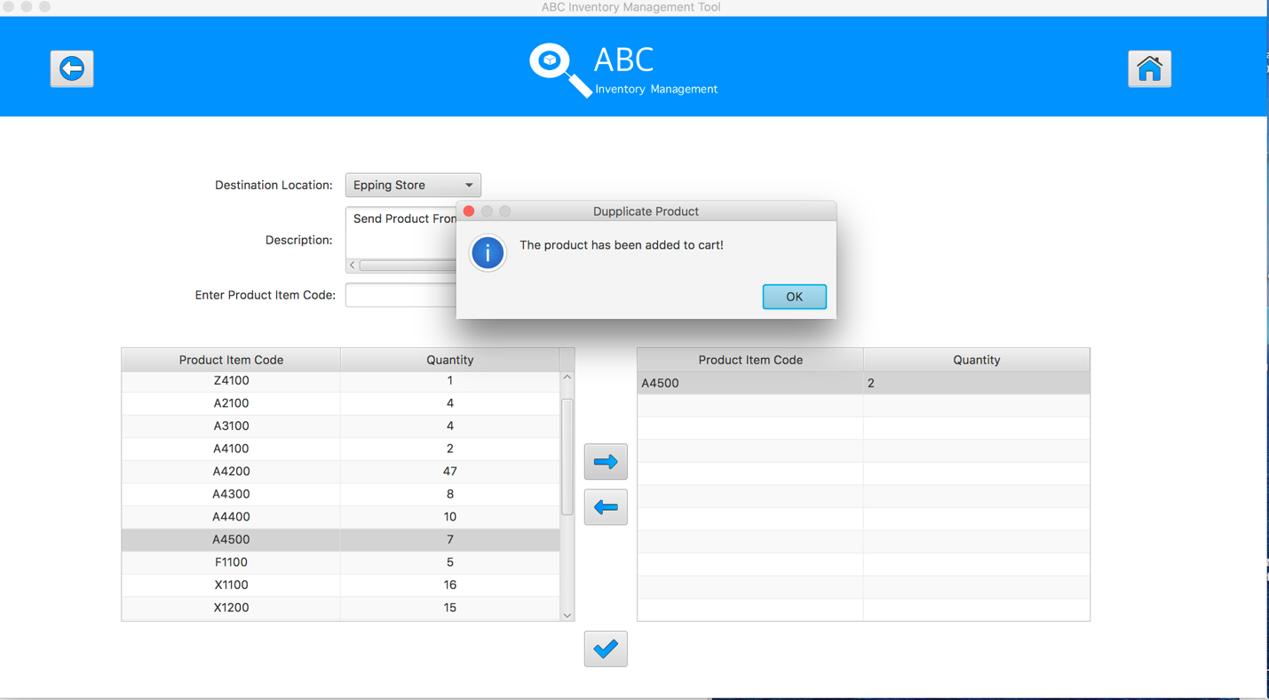

**Step 11**

Select the product item code in the table on the left

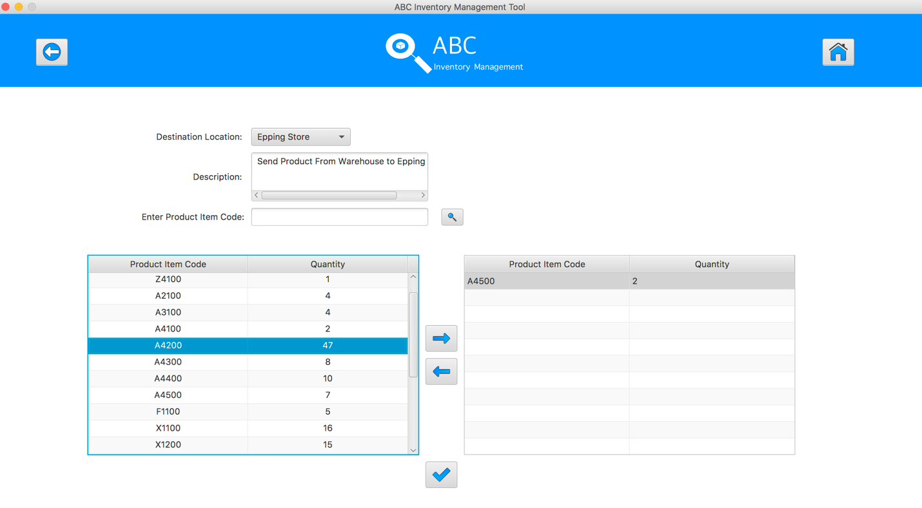

**Step 12**

Click on the “Add To Cart” Button

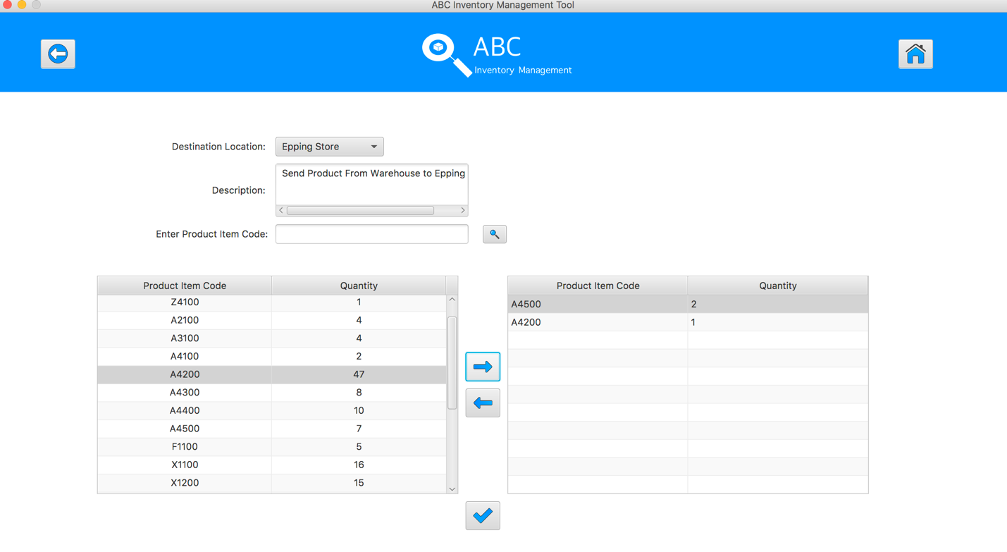

**Step 13**

Double click to the quantity cell in selected cart table

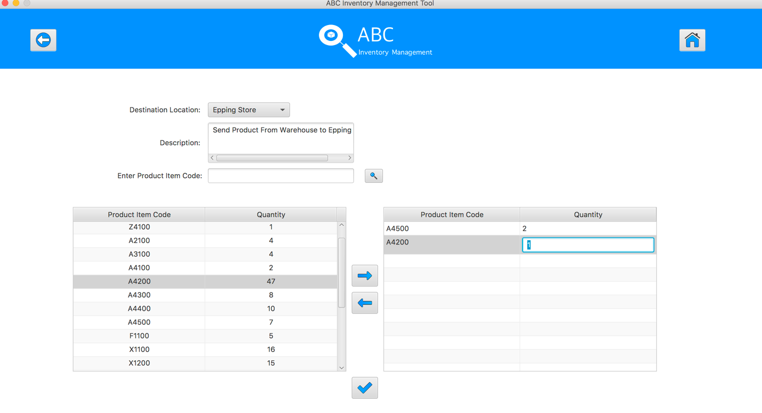

**Step 14**

Enter the desirable number

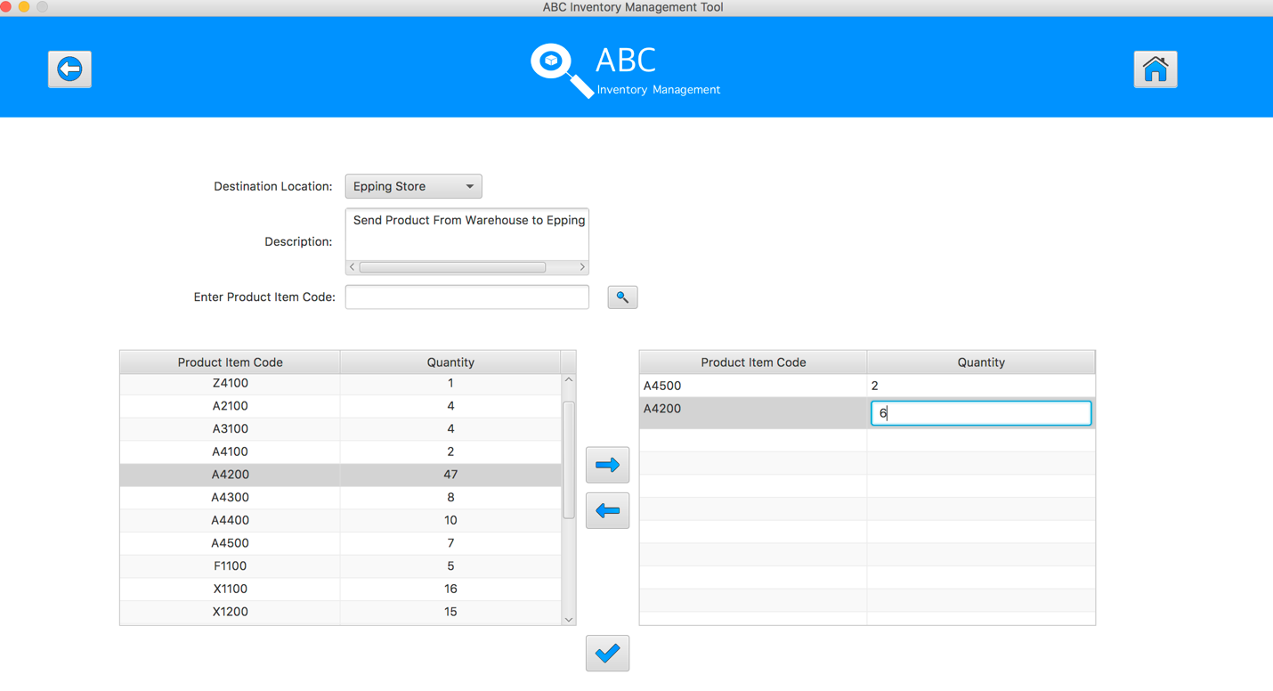

**Step 15**

Hit enter key to confirm this edited quantity

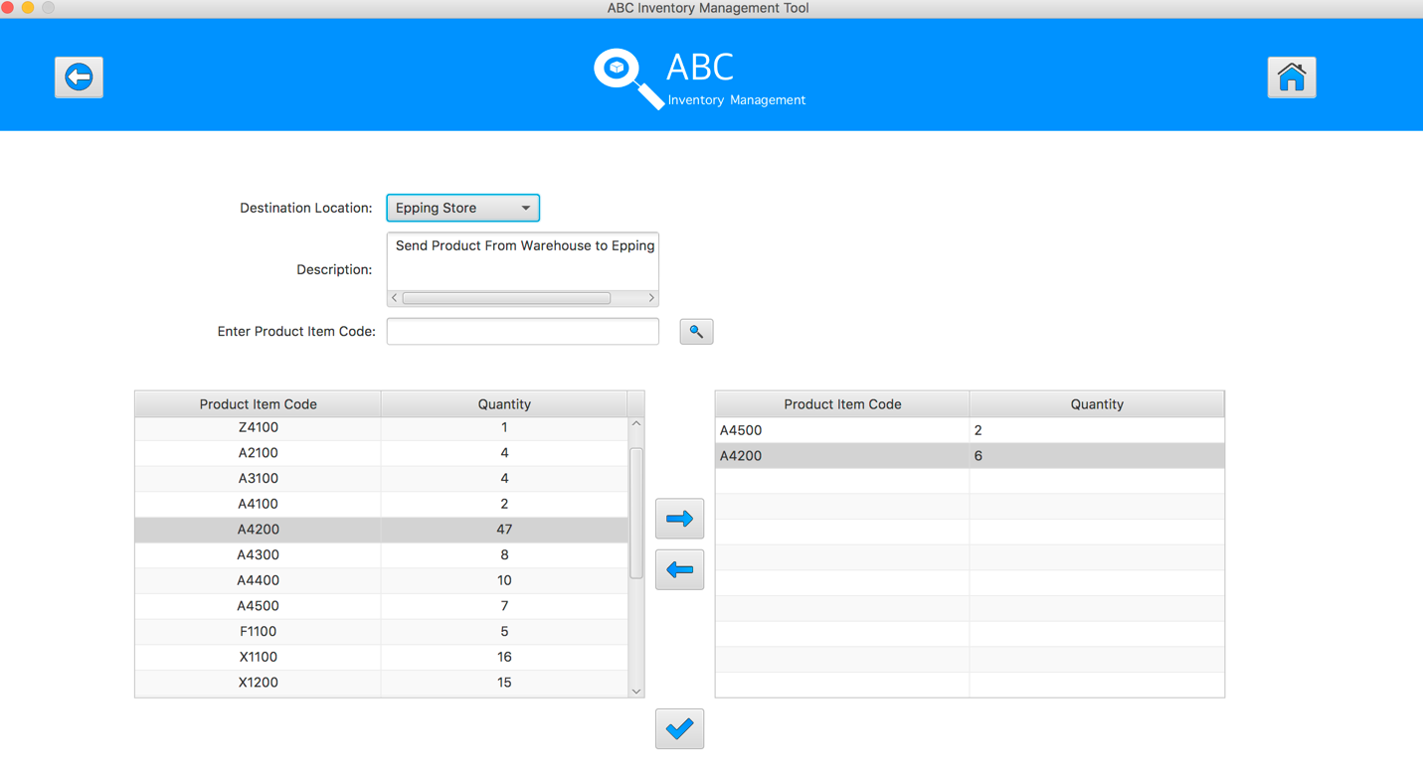

**Step 16**

After added the desirable items, hit the “Send Product” Button 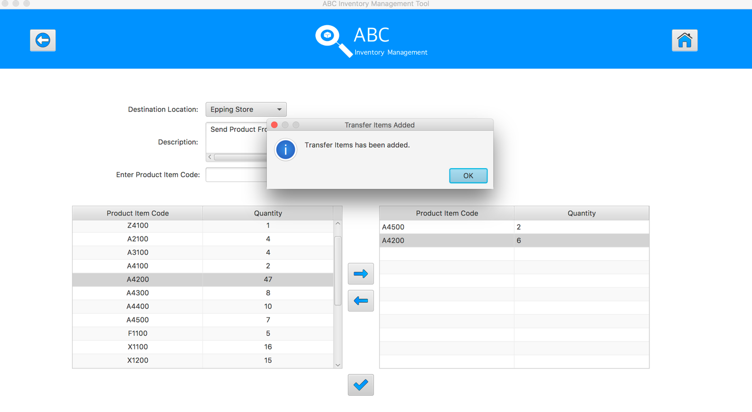

**Step 17**

Reset the interface for working with new transfer.

